**EXP NO: 17 View Last Activity of Your PC NAME : ADHIYAN PERIYAR R P**

**DATE: 18/09/2025 ROLL NO : 231901002**

**Aim :**

How to View Last Activity of Your PC

**Procedure :**

LastActivityView is a tool for Windows operating system that collects information from various sources on a running system, and displays a log of actions made by the

user and events occurred on this computer.

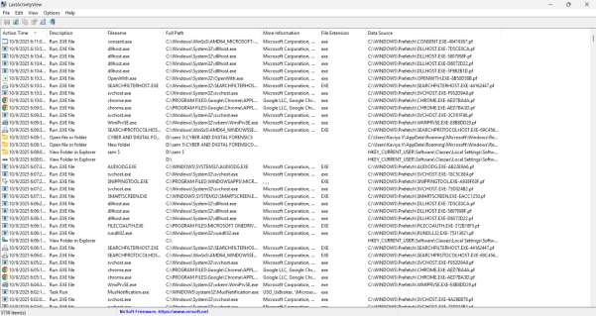

**Result:**

Thus, the forensic tools executed successfully, and the evidence was captured and analyzed accurately.